**E-commerce for Artisans**

project report submitted in

fulfillment of

**12 WEEK IEEE Internship**

BY

**VAIBHAV CHAND RANA UNIVROLL-2014933**

**SEC-A ROLL-59 SEMESTER-7Th**



**Department of computer science and engineering Graphic era deemed to be university**

**Session 2022-23**

# INDEX

|  |  |
| --- | --- |
| 1. **Abstract** | **3** |
| 1. **Abbreviation and Acronyms** | **4** |
| 1. **Introduction** | **5** |
| 1. **Proposed methodology** | **8** |
| 1. **Implementation** | **9** |
| * 1. **Technology used** | **9** |
| **4.2 Procedure** | **11** |
| 1. **Result Analysis** | **15** |
| 1. **Software requirements** | **18** |
| 1. **Hardware requirements** | **19** |
| 1. **Conclusion** | **19** |
| 1. **References** | **19** |

**ABSTRACT**

As we are moving in digital era everything which is present at physically are coming on online platforms. So, every retail shop owner faces the problem of constant fall of customers, reason being the digital platforms taking over the business world. To survive the entrepreneur competition going on, the local shop owners now have to take their business strategies to a new level, by including the digitalization and e-marketing for their business. They need to provide the clients/customers door-step service, where they can provide the customer the most reliable and an easy service.

But in this race of digitalization our craftsman who are very skillful left behind. So to provide aid in their day to day business and help them to sell their product I created this website which is known as ***artistan*.**

This website helps these artisans to help them in make profits in the earning and provide the customers the features that can ease in buying product according to his need.

**1-ABBREVIATION AND ACRONYMS:**

* **Artistan**: Name of website
* **Artisans**: a worker who practices a trade or handicraft
* **E-commerce**: the business of buying and selling things over the Internet
* **HTML:** Hypertext markup language
* **CSS**: cascading style sheet
* **SQL:** Structured query language
* **RDBMS:** relational database model
* **CRUD**: Create, read, update, delete

**2- INTRODUCTION:**

*Artistan* is an e-Commerce website which is made to help artist, craftsman and artisans. e-Commerce is a technique to trade or selling the product online using internet from any corner of the world. India is a very diverse country and this diversity lead to different art and artist through out the nation so to provide the aid in business of them I made this website.

According to Official data , India is home to >3,000 craft forms with artisans, spread across the country, working with papier-mâché in Jammu and Kashmir, thangka painting in Ladakh and Himachal Pradesh, phulkari and bagh textiles in Punjab, brassware in Haryana, basket-weaving in Uttaranchal, chikankari and zardozi work in Uttar Pradesh, blue pottery and block printing in Rajasthan, ajrak and kite making in Gujarat, gond painting in Madhya Pradesh, terracotta products and warli art in Maharashtra, crochet and lace work in Goa, sandalwood carving and banjara embroidery in Karnataka, vallam boat making in Kerala, thanjuvar kalamkari in Tamil Nadu, telia rumal and kondapalli toys in Andhra Pradesh, ikat work in Telangana, cane baskets in Nagaland, sikki grass products in Odisha, dhokra work in Jharkhand, kantha and patachitra crafts in West Bengal, madhubani paintings and mulberry silk products in Bihar, choktse tables in Sikkim, eri silk products in Assam and bamboo products in Chhattisgarh, Arunachal Pradesh, Manipur, Mizoram, Tripura and Meghalaya.

With its large population of artisans and diverse range of craft abilities, India has the potential to develop this business into a multibillion dollar one. But because everyone now wants everything at home without leaving the house, the number of clients is declining owing to the digital age. Customers want to order the products they want online, therefore this website enables artists to sell their goods while facilitating customer purchases.

**Advantages of this website:**

* Manufacture will list their production on website and sell directly to customer.
* Customer will be able to buy directly from manufacture.
* Person from any corner of country can buy.
* Payment can be made online within minutes.
* Wide categories of products can be present at one place.
* Store can be accessed via mobile, laptop or PC.

**3.1 STATEMENT OF THE PROBLEM:**

Traditionally, customers are used to buying the products at the real, in other words, factual shops or supermarkets. It needs the customers to show up in the shops in person, and walk around different shopping shelves, and it also needs the owners of shops to stock, exhibit, and transfer the products required by customers. It takes labour, time and space to process these operations. Furthermore, the spread of the Covid-19 pandemic has caused a lot of changes in our lifestyle, people fearing to get outside their homes, transportation almost shut down and social distancing becoming all the more important. Big to small scale business that relied on the traditional incur a lot of consequence due to the lockdown issues. Some tend to more towards using social media platforms like Facebook to sell their product. However, the social media platforms have been beneficial for marketing purposes alone but leaves the whole task of customer and massive order management via direct messaging (DM), which takes a lot of time to respond to all customers. In addition, everyone tends to use social media, posing a great challenge to differentiatebetween scammers (fraudsters) and legit sellers**.** So my task is to develop an **E-commerce website for artisans** which has all modern features and easy to use.

**3.2 THE SOLUTION:**

**Artistaan** is an Online shopping system provides a solution to reduce and optimize these expenses. Authorized Customers do not need to go to the factual shops to choose and bring the products they need by hands. They simply browse their Personal computers or cell phones to access shops, and evaluate the products description, pictures on the screen to choose products. In addition, the owners of the shop do not need to arrange or exhibit their stocks products. They just input the description, prices of products, and upload their pictures. Simply, both customers and shop owners do not need to touch the real products in the whole process of shopping, and management. In the end the logistic centre will distribute the products required by customers, or products ordered by shop owners to their locations. The customers can track the status of their orders until delivery, after which they can leave a review of the type of service they received. The payment and products’ quantity will be saved in database through the data flow. These shopping, management and distribution processes greatly simplify and optimize the retail business. Due to this our skilled craftsman are able to expand their business in national level without much expenses and anyone from the country can buy their products.

**3.3 SCOPE AND LIMITATION**

Every project is done to achieve a set of goals with some conditions keeping in mind that it should be easy to use, feasible and user friendly. As the goal of this project is to develop an online E-commerce brochure system, this system will be designed keeping in mind the conditions (easy to use, feasibility and user friendly) stated above. It may help in effective and efficient order management. In every shot time, the collection will be obvious, simple and sensible. It is very possible to observe the customer potentials and purchase patterns because all the ordering history is store in the database. It is efficient managing all the operations of an online store within a single platform. The project aims to automate the business process of Artisan’s business The proposed project would cover:

**Customer Side:**

• Customer can view/search products without login.

• Customer can also add/remove product to cart without login (if customer try to add

same product in cart. It will add only one)

• When customer try to purchase product, then he/she must login to system.

• After creating account and login to system, he/she can place order.

• If customer click on pay button, then their payment will be successful and their

order will be placed.

• Customer can check their ordered details by clicking on orders button.

• Customer can see the order status (Pending, Confirmed, Delivered) for each order

**Admin Side:**

* Admin will able to login and register
* Admin home page
* Dashboard
* Add products
* Delete products
* Edit product and their image
* Add, remove, and edit description
* Add category
* Delete category
* Add or remove manufacturer
* Accept or reject order
* View order
* View payments
* Logout

**3.4-** **METHODOLOGY USED**

For developing this project, I use iterative waterfall model because the requirements are clear from the beginning. After deciding the model first I collected all the requirements through some research and by looking at different websites like flipkart and amazon. After getting the requirement, write down each requirement and start designing the architecture of website.

In designing phase, first decide the front end. Design for frontend should be simple, attractive and beginner friendly. For frontend I choose html, CSS and JavaScript and bootstrap framework. Once frontend is completed then I designed the database schemas and design the relationship between them. For database I used SQLite which is a RDBMS.

Database has many tables like one for storing the information of user, one for storing the admins details, one for storing the products and cart item and many more.

The product data should be upload by the admin, he can edit delete or modify the uploaded data. Users can add items into cart and order as many quantities as they wants.

After finishing the database design, I decided to make completely dynamic website using Django. Django is lightweight scripting language which runs at server side.

**4- IMPLEMENTATION:**

**4.1 TECHNOLOGIES USED:**

Technologies that are used to develop this project are as follows:

**4.1.a HTML –**

HTML stands for Hypertext Markup Language. It is used to design web pages using a markup language. HTML is the combination of Hypertext and Markup language. Hypertext defines the link between the web pages. A markup language is used to define the text document within tag which defines the structure of web pages. This language is used to annotate (make notes for the computer) text so that a machine can understand it and manipulate text accordingly. Most markup languages (e.g. HTML) are human-readable. The language uses tags to define what manipulation has to be done on the text.

HTML is a markup language used by the browser to manipulate text, images, and other content, in order to display it in the required format. HTML was created by Tim Berners-Lee in 1991.

**4.1.b CSS:**

CSS stands for Cascading Style Sheets is a stylesheet language used to design the webpage to make it attractive. The reason of using CSS is to simplify the process of making web pages presentable. CSS allows you to apply styles to web pages. More importantly, CSS enables you to do this independent of the HTML that makes up each web page. Lets understand with an example , HTMl creates the skeleton of web page . html is not concern about user interface but to make our page attractive we use css to cover the skeleton and add beauty to it

**4.1.c JavaScript:**

JavaScript is a scripting or programming language that allows you to implement complex features on web pages — every time a web page does more than just sit there and display static information for you to look at — displaying timely content updates, interactive maps, animated 2D/3D graphics, scrolling video jukeboxes, etc. — you can bet that JavaScript is probably involved. It is the third layer of the layer cake of standard web technologies.

**4.1.d Bootstrap:**

Bootstrap is the most popular HTML, CSS and JavaScript framework for developing a responsive and mobile friendly website. It is absolutely free to download and use. It is a front-end framework used for easier and faster web development. It includes HTML and CSS based design templates for typography, forms, buttons, tables, navigation, modals, image carousels and many others. It can also use JavaScript plug-ins. It facilitates you to create responsive designs.

**4.1.e SQLite**

SQLite is an in-process library that implements a self-contained, serverless, zero-configuration, transactional SQL database engine. It is a database, which is zero-configured, which means like other databases you do not need to configure it in your system.

## SQLite engine is not a standalone process like other databases, you can link it statically or dynamically as per your requirement with your application. SQLite accesses its storage files directly.

**4.1.f Django:**

Django is a high-level Python web framework that enables rapid development of secure and maintainable websites. Built by experienced developers, Django takes care of much of the hassle of web development, so you can focus on writing your app without needing to reinvent the wheel. It is free and open source, has a thriving and active community, great documentation, and many options for free and paid-for support. Django works in MVT pattern which is model, view and template.

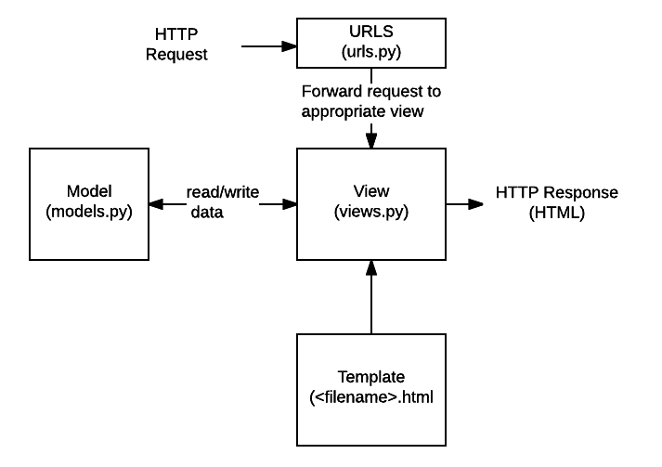

Fig 1.0 (MVT structure of Django)

**MVT Structure has the following three parts –**

* **Model**: The model is going to act as the interface of your data. It is responsible for maintaining data. It is the logical data structure behind the entire application and is represented by a database (generally relational databases such as MySql, Postgres).
* **View**: The **View** receives HTTP requests and sends HTTP responses. A view interacts with a model and template to complete a response.
* **Templates**: The Template is basically the front-end layer and the dynamic HTML component of a Django application. It contains HTML, CSS and JAVASCRIPTS.

**4.2 Implementation Procedure:**

**4.2.1 Customer Interface:**

First the frontend for customers is developed and for this there are some dummy data in data inside database tables and UI is developed using HTML, CSS and JavaScript And Django is used to organize the code such as include method in Django is used to include any other Django script inside one Django script. The features developed inside this are as follows:

* Home page
* Customer login and registration page
* Add to cart functionality
* View product
* Cart product before checkout
* Select size of product
* Select quantity
* Edit and delete account
* Remove item from the cart
* Order the item that are present inside the cart.

**4.2.2 Admin Interface:**

After finishing the customer UI now it is turn for admin interface the procedure for admin frontend is same as customer frontend. After designing the frontend it is turn for connecting admin to database and make the website completely dynamic using Django.

Most of the CRUD operation are performed here. The feature of admin interface are follows:

* Admin login and registration
* Admin home page
* Dashboard
* Add products
* Delete products
* Edit product and their image
* Add, remove and edit product features and description
* Add category
* Delete category
* Add or remove manufacturer
* Delete user
* Accept or reject order
* View order
* View payments
* Logout

**4.3 FLOW CHART:**

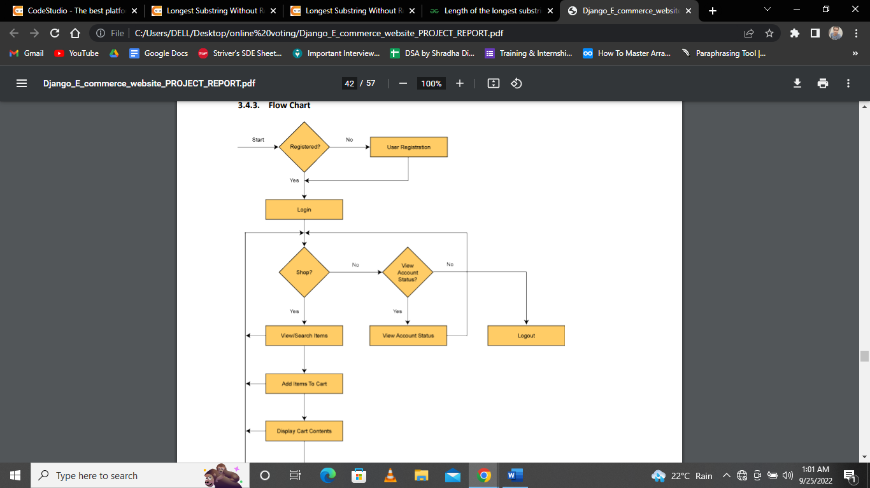

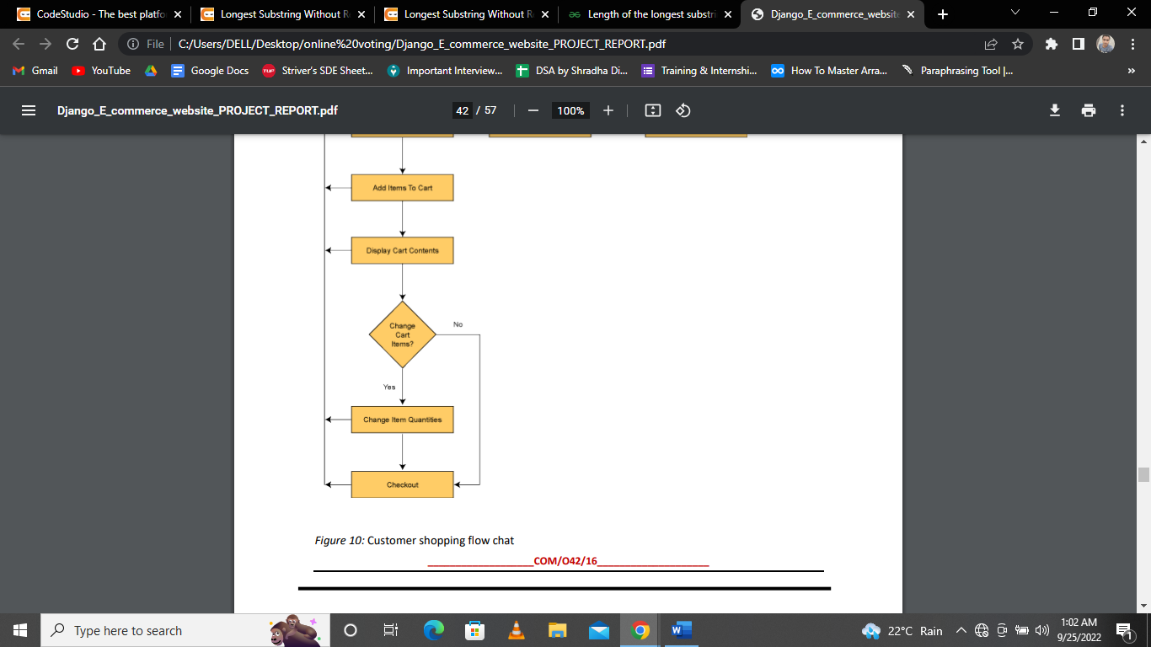

FIG 2.0 (Flow Chart For Artistaan)

**4.4 USE CASE DIAGRAM:**

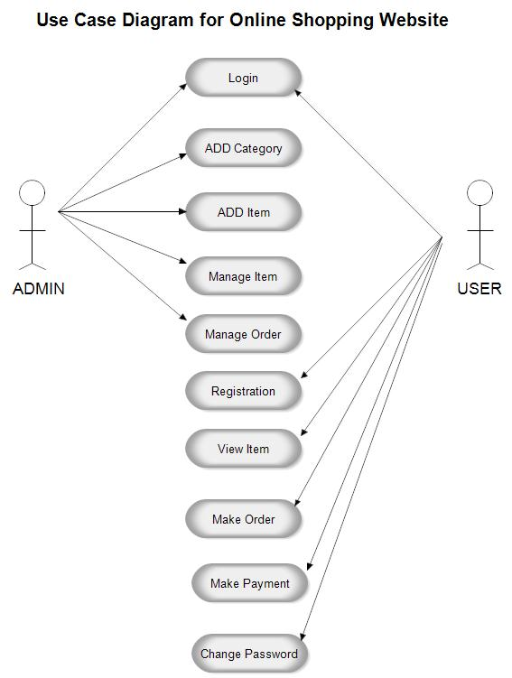

Fig 3.0 (Use Case For Artistaan )

**5 - RESULT ANALYSIS:**

Some screenshot of website artisans are follows:

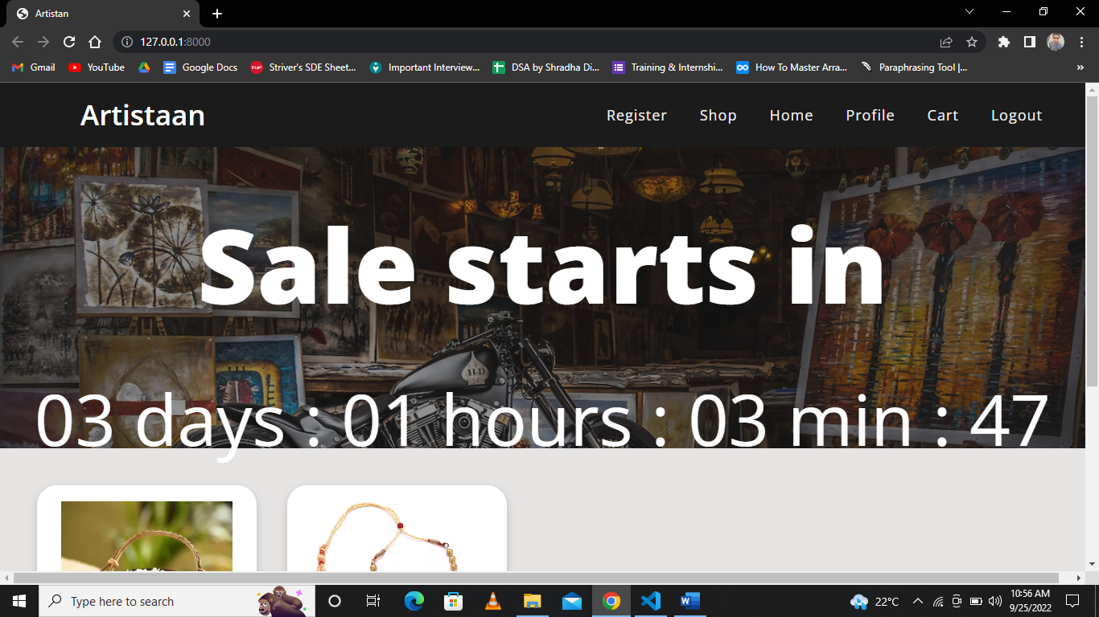

**Fig 5.1 – Home page**

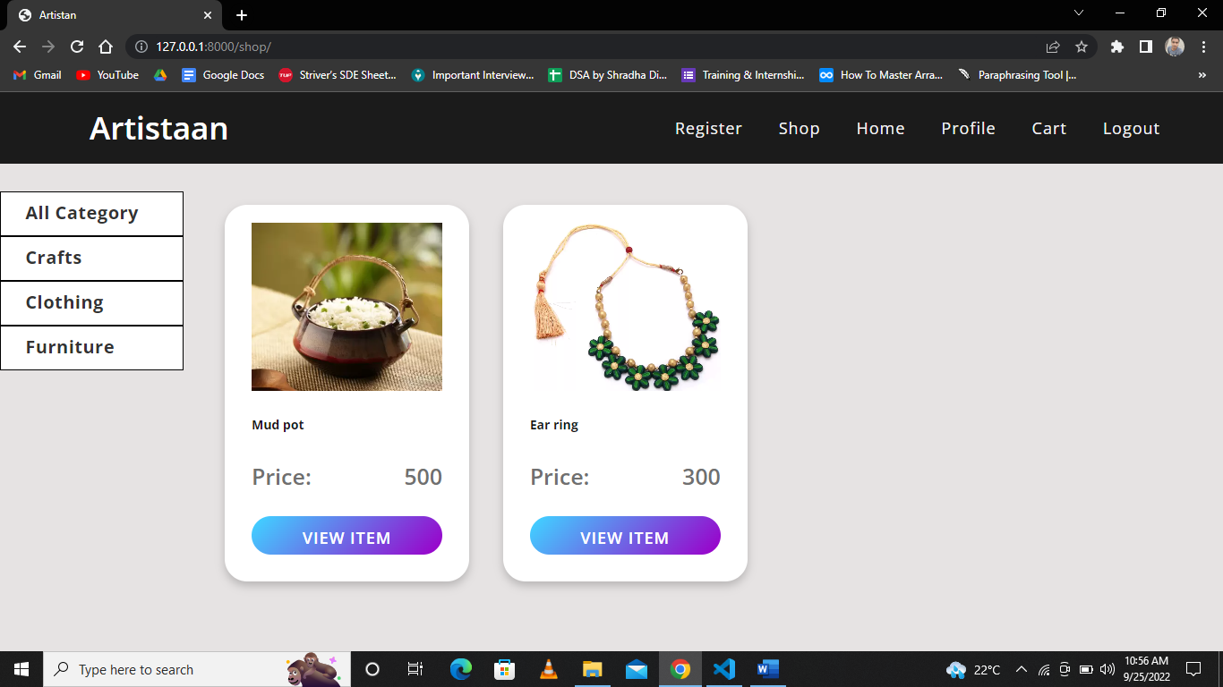

**Fig 5.2 – shopping area**

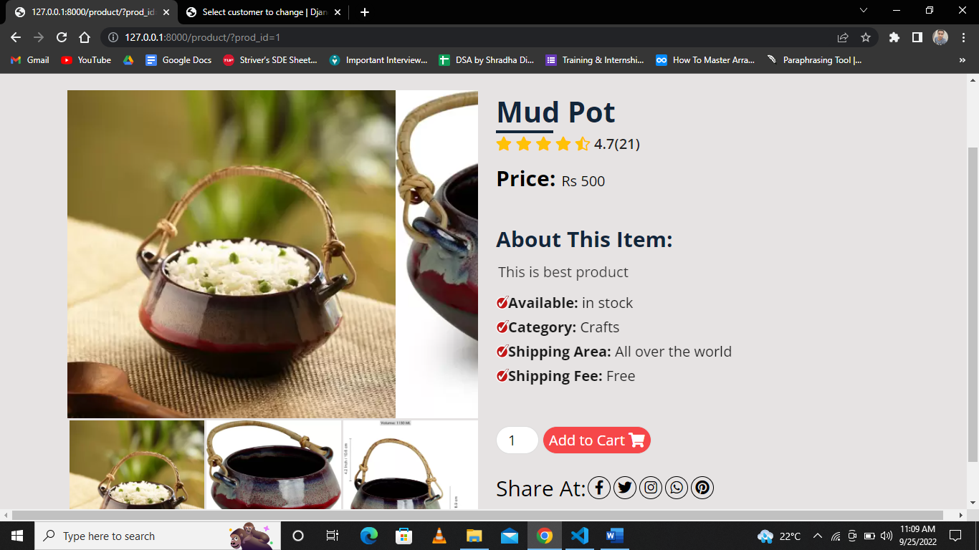

**Fig: Product Description**

**Fig5.3 - Login page**

**Fig 5.4- Registration Page**

**Fig 5.5 – cart page**

**Fig-5.6 Checkout Page**

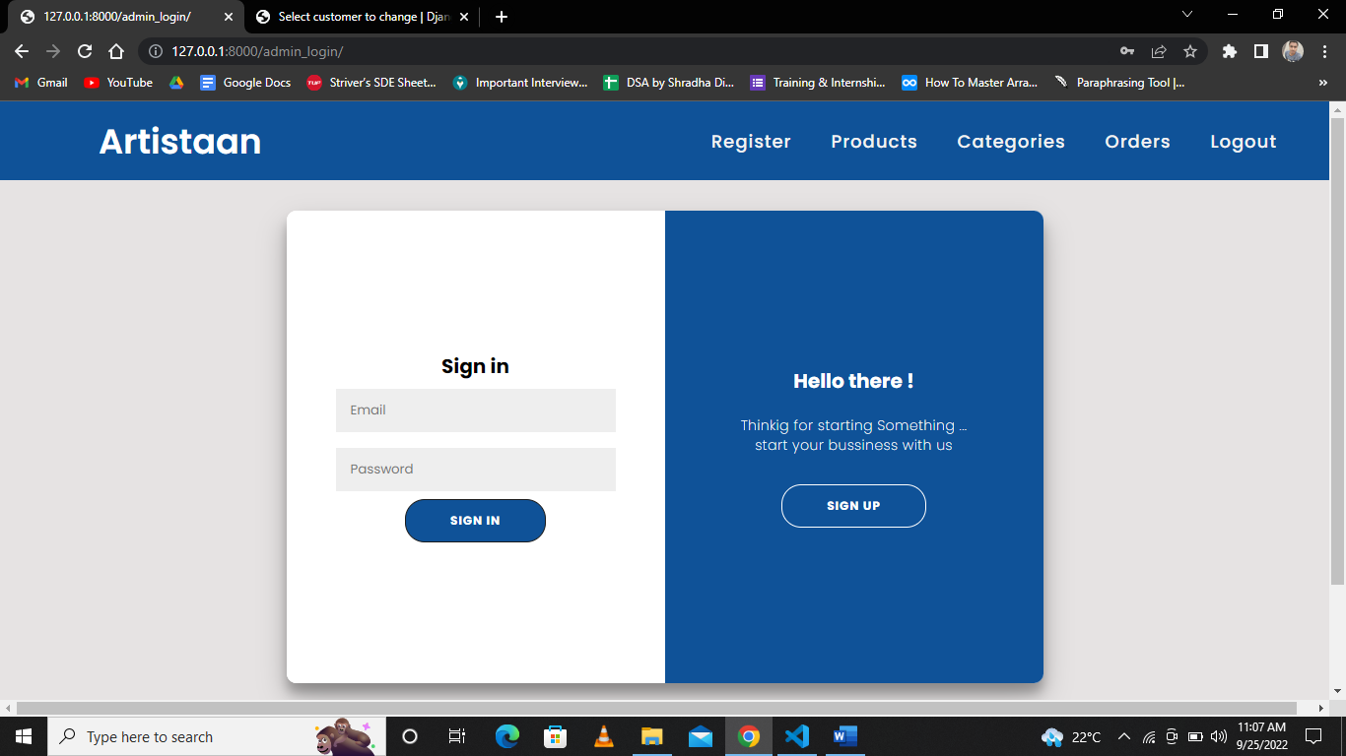

**Fig5.7 Admin Login and Registration**

**6- SOFTWARE REQUIREMENTS:**

* HTML
* CSS
* JAVASCRIPT
* Django
* SQLite
* DB browser
* ANY MODERN BROWSER

**7- HARDWARE REQUIREMNTS:**

* PHONE/PC/LAPTOP/TABLET
* MORE THAN 2 GB RAM
* STABLE INTERENET CONNECTION

**8- CONCLUSION:**

I have successfully implemented the website artistan using various tools and technology and now it is turn and its deployment on internet to ready to use. This website is just an attempt to provide help for artisan by giving them a platform where can sell their goods and increase their business domain all over the world and now any person can take benefit of their product sitting in any corner of India. This website gives a lot of features for both seller and buyer and in future I try to enhance it as much as I can.

**9- REFERENCES:**

* + Youtube.com (https://www.youtube.com/)
  + Django documentation (https://docs.djangoproject.com/en/4.1/)
  + Mdn documentation (https://developer.mozilla.org/en-US/docs/Web/)
  + Bootstrap 5 documentation (https://getbootstrap.com/docs/5.0/getting-started/introduction/)